**Department of Electrical Engineering and   
Computer Science**

**Faculty Member:** Dr. Mohsin Kamal **Dated:** DD/MM/2023

**Semester:** 7th **Section:** BEE 12C

**CS-477 Computer Vision**

Lab #: Title

**Group Members**

|  |  |  |  |  |  |  |
| --- | --- | --- | --- | --- | --- | --- |
|  |  | **PLO4 - CLO4** | | **PLO5 -CLO5** | **PLO8 -CLO6** | **PLO9 -CLO7** |
| **Name** | **Reg. No** | **Viva / Quiz / Lab Performance** | **Analysis of Data in Lab Report** | **Modern Tool Usage** | **Ethics and Safety** | **Individual and Teamwork** |
|  |  | **5 Marks** | **5 Marks** | **5 Marks** | **5 Marks** | **5 Marks** |
| Muhammad Ahmed Mohsin | 333060 |  |  |  |  |  |
| Muhammad Umer | 345834 |  |  |  |  |  |
|  |  |  |  |  |  |  |
|  |  |  |  |  |  |  |

**Table of Contents**

2 Title 3

2.1 Introduction 3

2.2 Objectives 3

2.3 Software 3

3 Lab Tasks 4

3.1 Task 1 4

3.2 Task 2 4

3.3 Task 3 4

4 Conclusion 4

# Title

## Introduction

## Objectives

The following are the main objectives of this lab:

## Software

Python is an open source, interpreted language which is widely used for machine learning tasks in research, academia, and industry. It has an easy-to-learn syntax and is ideal for writing programs in a short duration. The python interpreter can be downloaded from the website and installed on the system. By default, the IDLE program is installed. For machine learning, it is recommended to switch to a more powerful IDE such as PyCharm, Spyder, and Jupyter, etc.

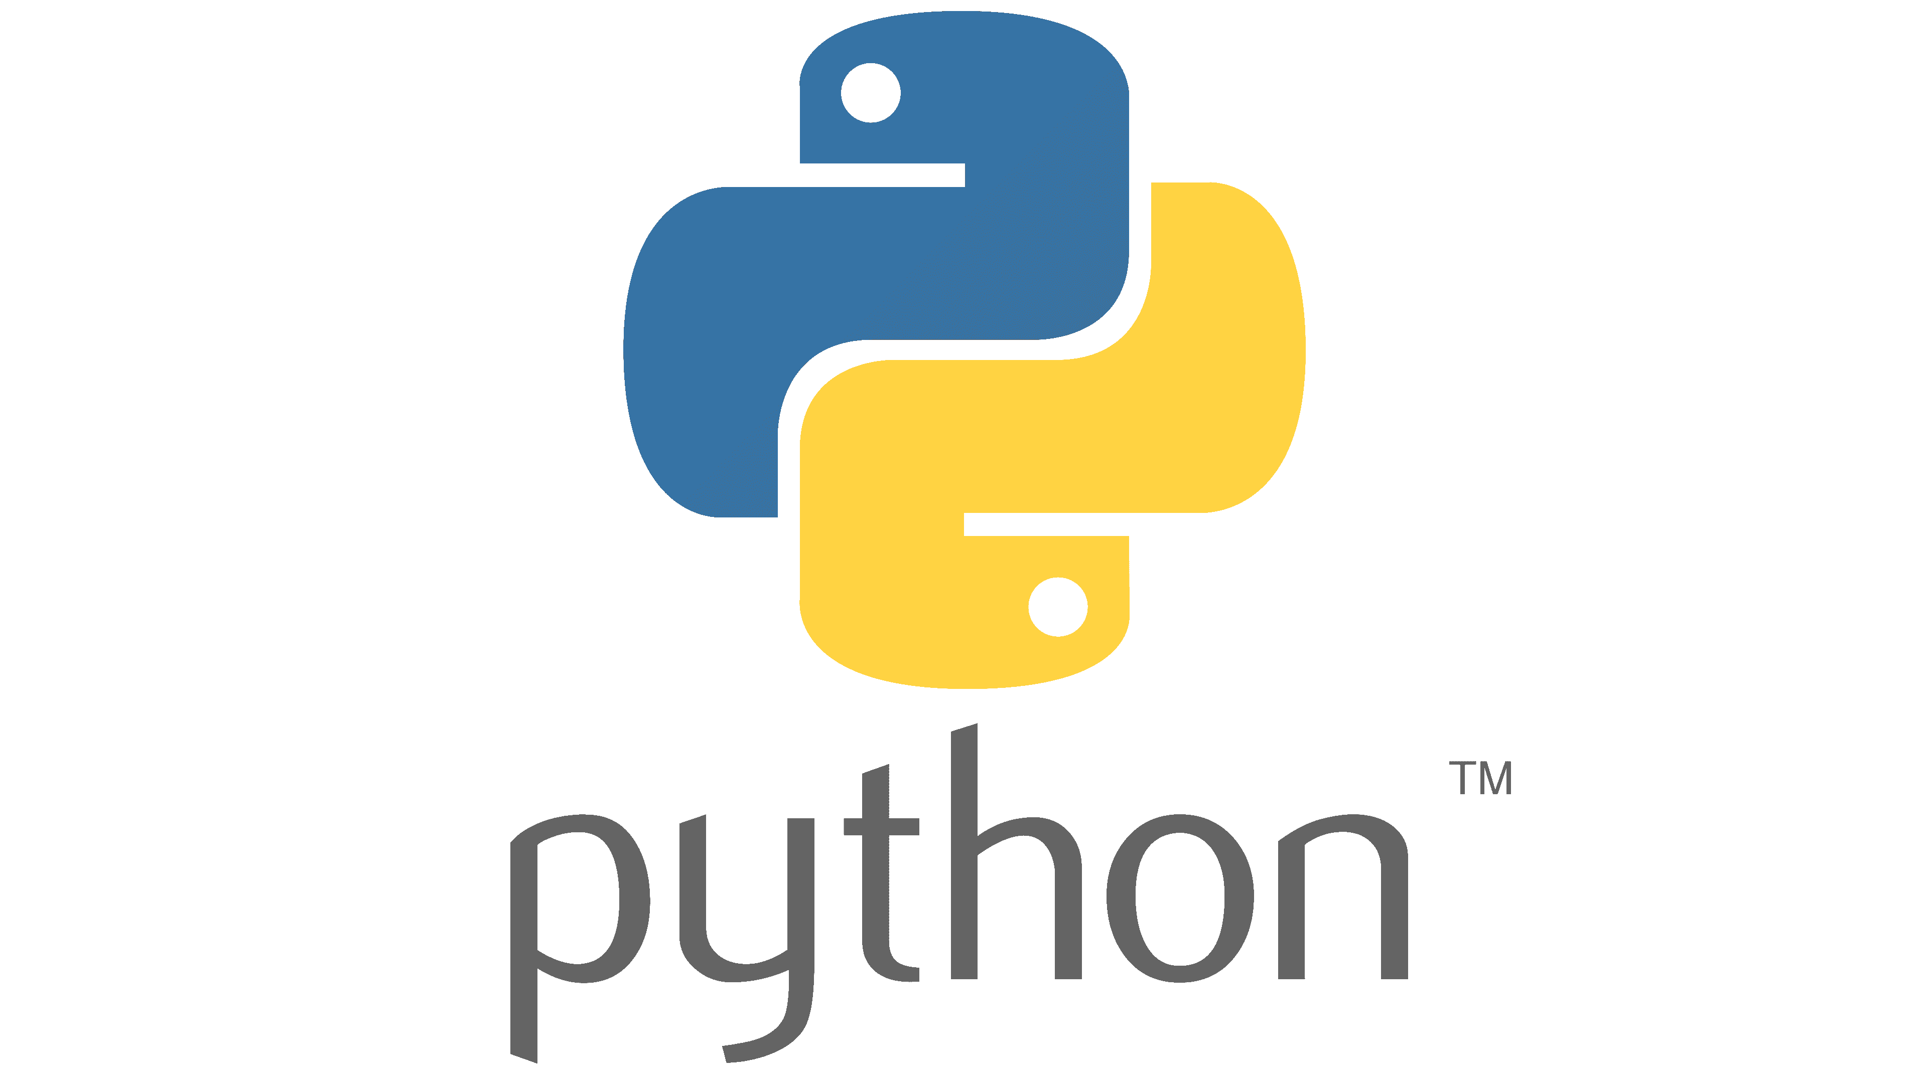

# Lab Tasks

## Task 1

### Task 1 Code Starts Here ###

### Task 1 Code Ends Here ###

### Task 1 Screenshot Starts Here ###

### Task 1 Screenshot Ends Here ###

## Task 2

### Task 2 Code Starts Here ###

### Task 2 Code Ends Here ###

### Task 2 Screenshot Starts Here ###

### Task 2 Screenshot Ends Here ###

## Task 3

### Task 3 Code Starts Here ###

### Task 3 Code Ends Here ###

### Task 3 Screenshot Starts Here ###

### Task 3 Screenshot Ends Here ###

# Conclusion